IMPLEMENTATION OF LINKED LIST USING LINEAR SEARCH AND BINARY SEARCH USING ADT

AIM:
To implement Linear Search and Binary Search using functions in C and search for a given element in an array.

Pseudo Code:
START

Step 1: Read number of elements n

Step 2: Create a linked list
Repeat n times:
Create a new node
Enter data
Add node to the list

Step 3: Display the linked list

Step 4: Perform Linear Search
Enter search element
Compare each node data with the key
If found, display position
Otherwise display "Not Found"

Step 5: Perform Binary Search
Enter sorted array elements
Enter search element
Set low = 0 and high = n-1

Repeat while low <= high:
Find middle element
If middle element equals key
Display position
Else if key is smaller
Search left half
Else
Search right half

Step 6: If element is not found
Display "Not Found"
STOP
PROGRAM:
#include <stdio.h>
#include <stdlib.h>

struct node {
int data;
struct node *next;
} *head = NULL;

int main() {
int n, i, key, low, high, mid;
struct node *newnode, *temp;

printf("Enter number of elements: ");
scanf("%d", &n);

// Create Linked List
printf("Enter elements:\n");
for(i = 0; i < n; i++) {
newnode = (struct node *)malloc(sizeof(struct node));
scanf("%d", &newnode->data);
newnode->next = NULL;

if(head == NULL)
head = newnode;
else {
temp = head;
while(temp->next != NULL)
temp = temp->next;
temp->next = newnode;
}
}

// Display Linked List
printf("Linked List: ");
temp = head;
while(temp != NULL) {
printf("%d ", temp->data);
temp = temp->next;
}

// Linear Search
printf("\nEnter element for Linear Search: ");
scanf("%d", &key);
temp = head;
i = 1;
while(temp != NULL) {
if(temp->data == key) {
printf("Found at position %d\n", i);
break;
}
temp = temp->next;
i++;
}
if(temp == NULL)
printf("Not Found\n");

// Binary Search
int a[n];
printf("Enter %d sorted elements for Binary Search:\n", n);
for(i = 0; i < n; i++)
scanf("%d", &a[i]);

printf("Enter element for Binary Search: ");
scanf("%d", &key);

low = 0;
high = n - 1;

while(low <= high) {
mid = (low + high) / 2;
if(a[mid] == key) {
printf("Found at position %d\n", mid + 1);
return 0;
}
else if(key < a[mid])
high = mid - 1;
else
low = mid + 1;
}

printf("Not Found\n");

return 0;
}

OUTPUT:
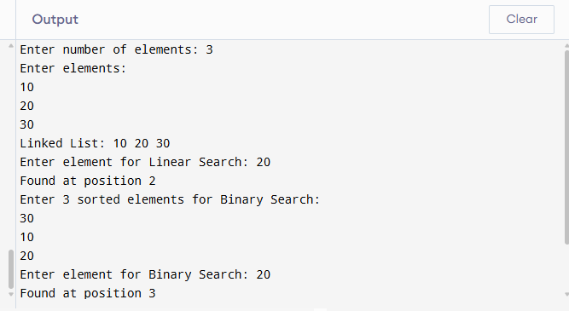

RESULT:
The program was implemented successfully to create a linked list and perform Linear Search on the linked list. It also performs Binary Search on sorted elements and displays whether the required element is found or not.

